CAVALCADE OF AUTHORS WEST 2015
T-SHIRTS AVAILABLE
Front Back
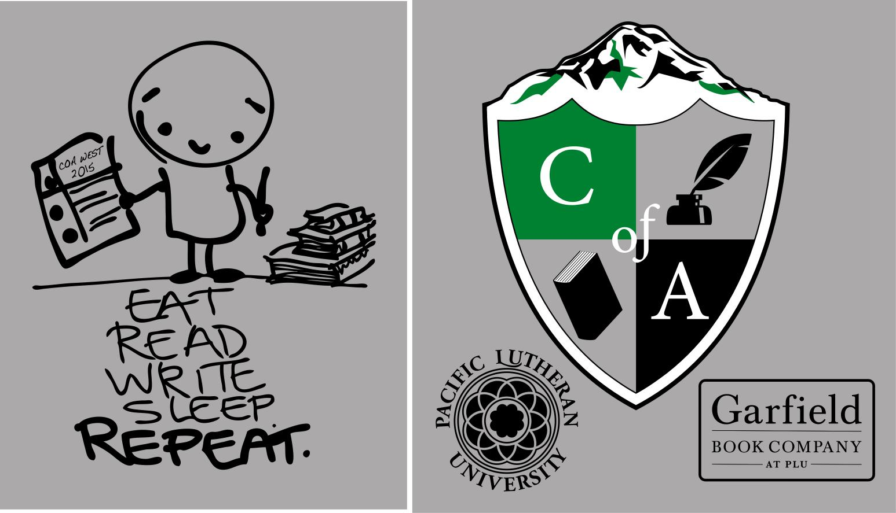

Need a perfect memento of your first Cavalcade of Authors West event? Want to collect all of your autographs in one place?
Then you need a COA West 2015 T-shirt!

Shirts sold online only through Winning Seasons (winningseasons.net)
*Find Cavalcade of Authors West under “Team Sales”*

Shirts are $10 and will be distributed at check-in at COA West on Saturday, May 2nd.

Sales are open now, but will close on April 6th. There will be no shirts available for sale the day of the event. Order yours today!

cavalcadeofauthorswest.com
@cavalcadewest Twitter | Instagram
#COAWest15

